String Operations in Python

1. Find the length of the string

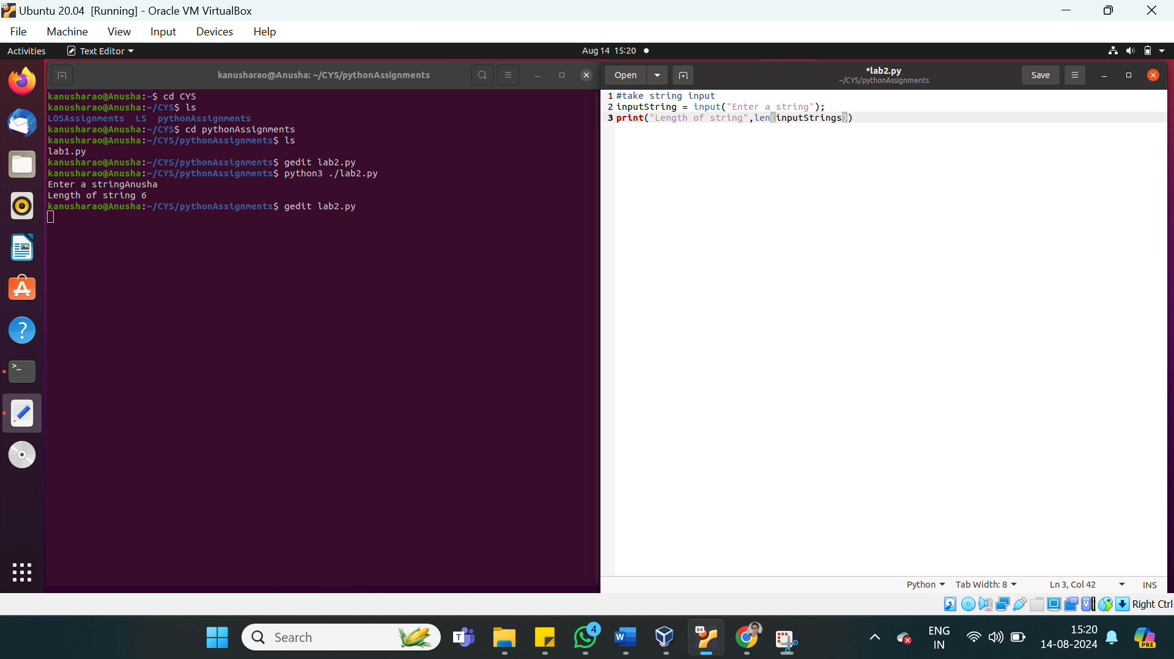

2. Slice the string as per your choice

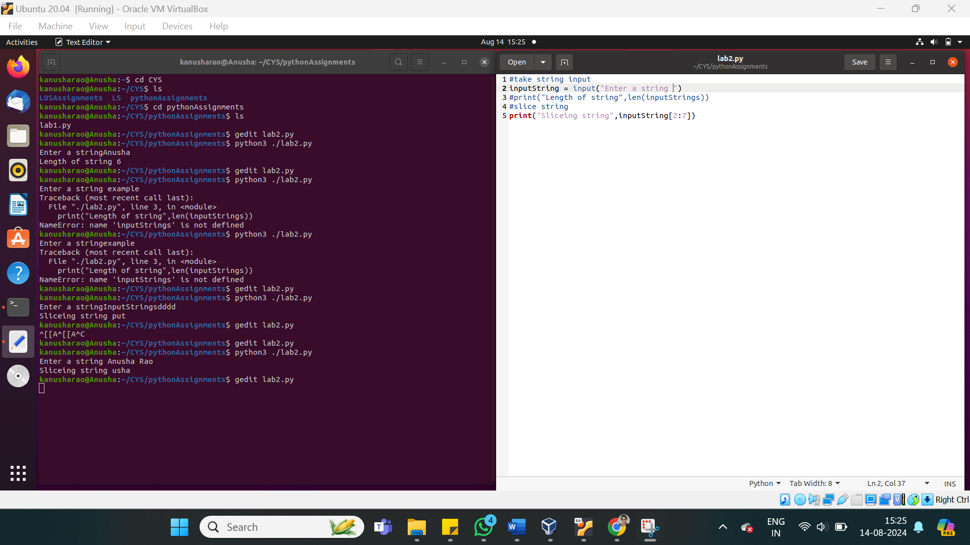

3. Concatenate two strings

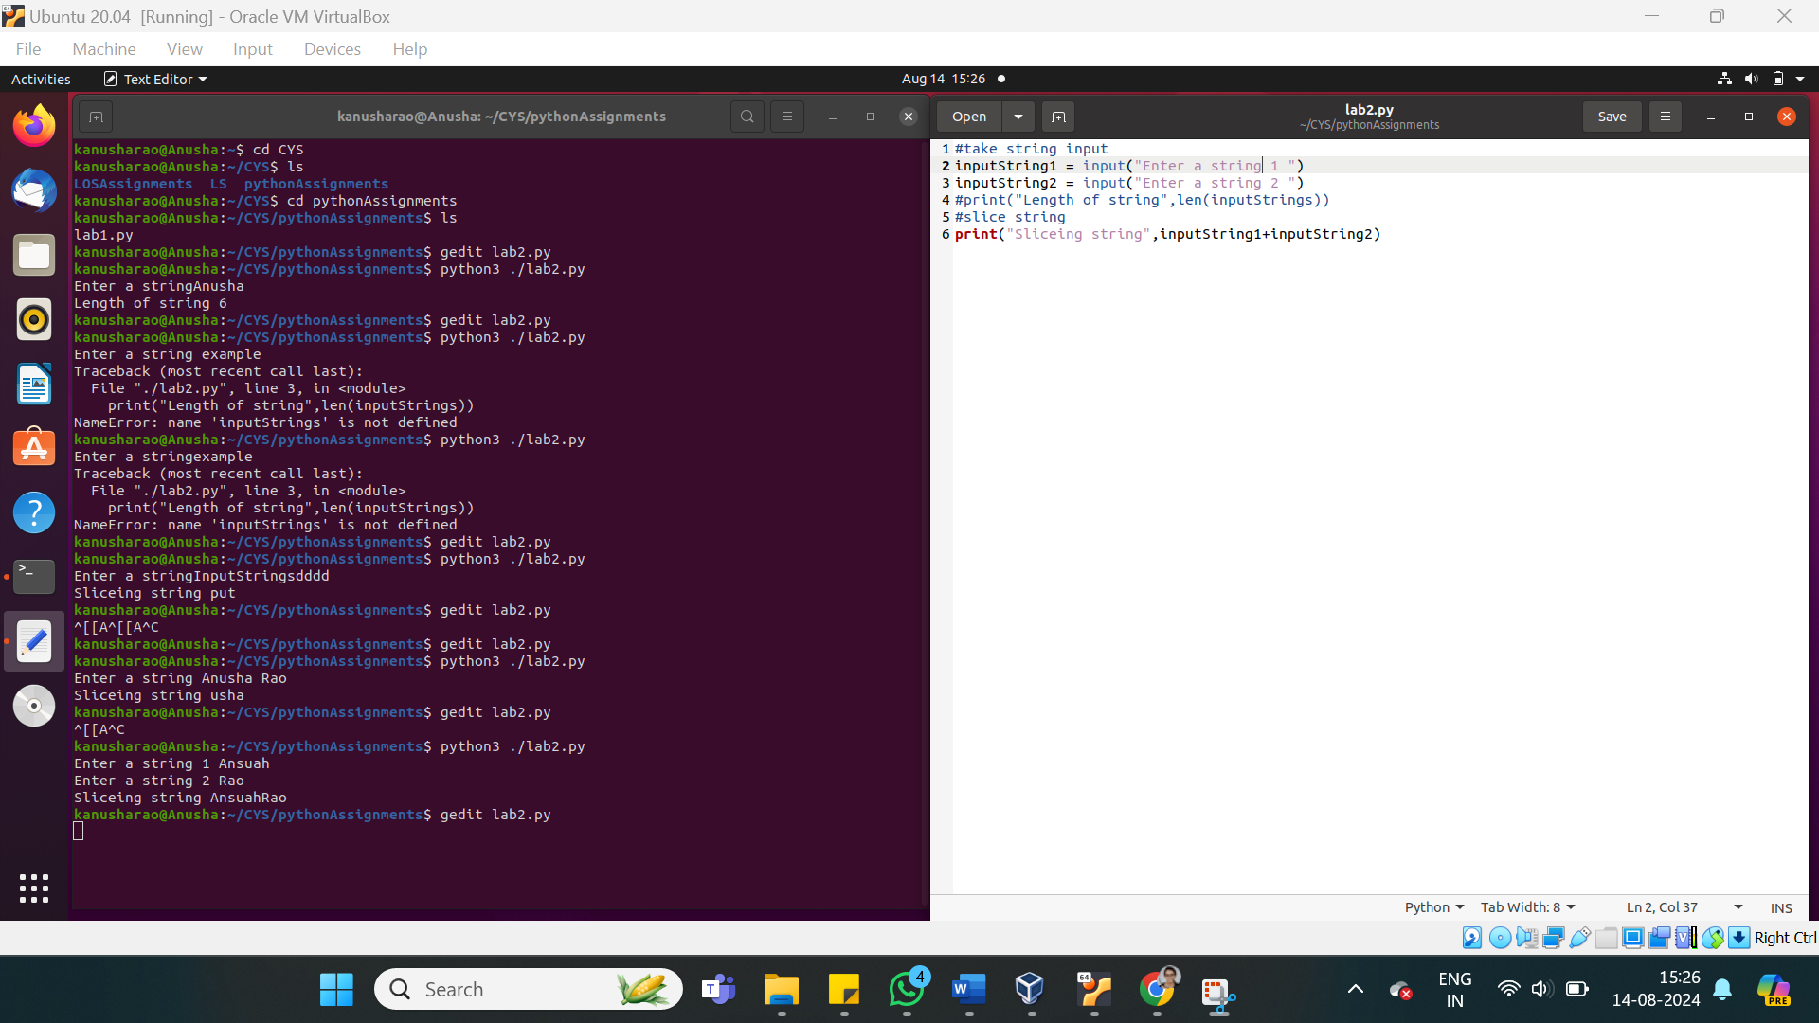

4. Convert in to lower case in to uppercase character

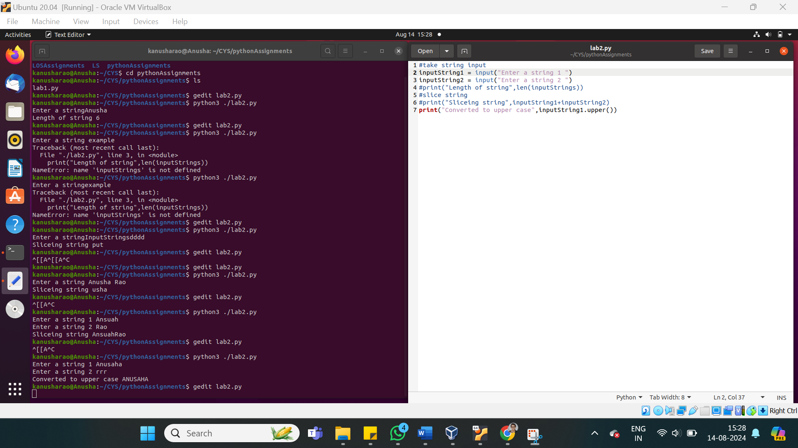

5. Convert upper case into lower case characters

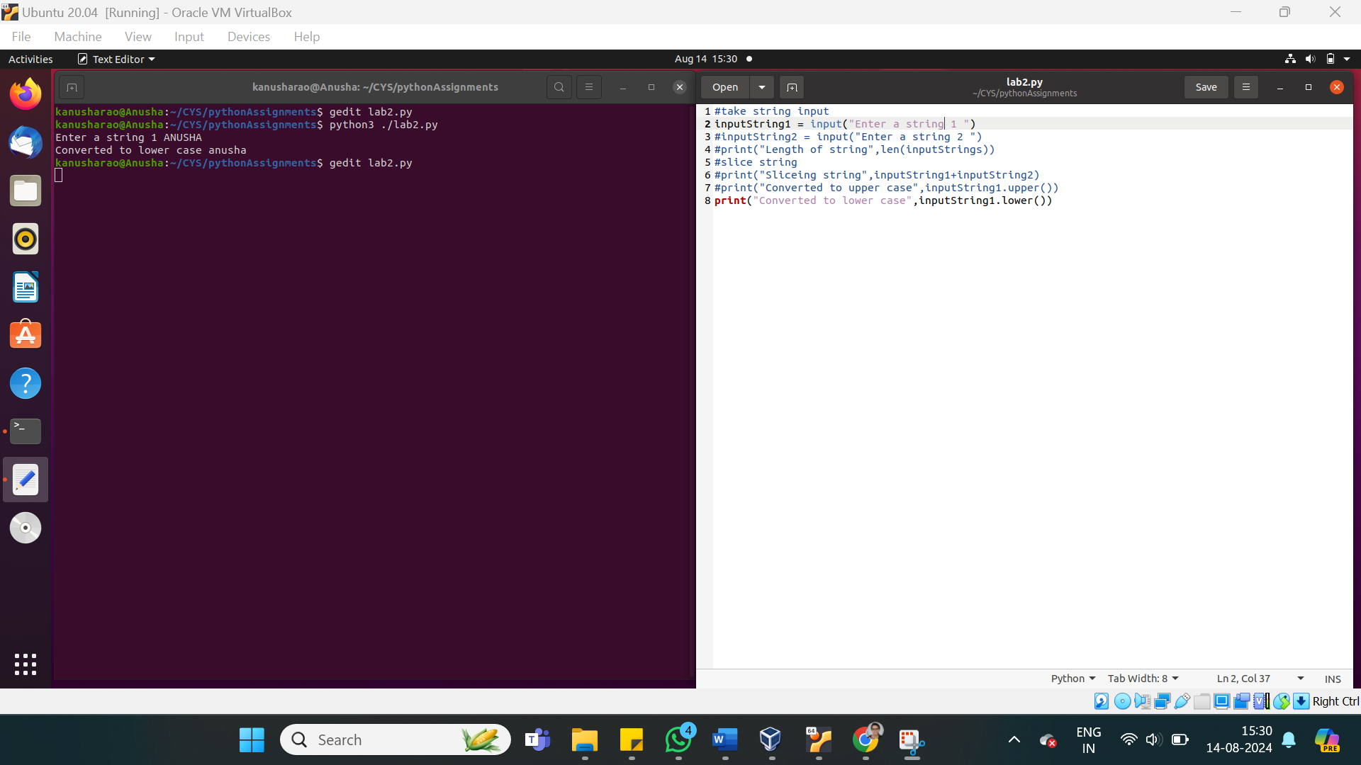

6. convert the character into Unicode ( Ascii values)

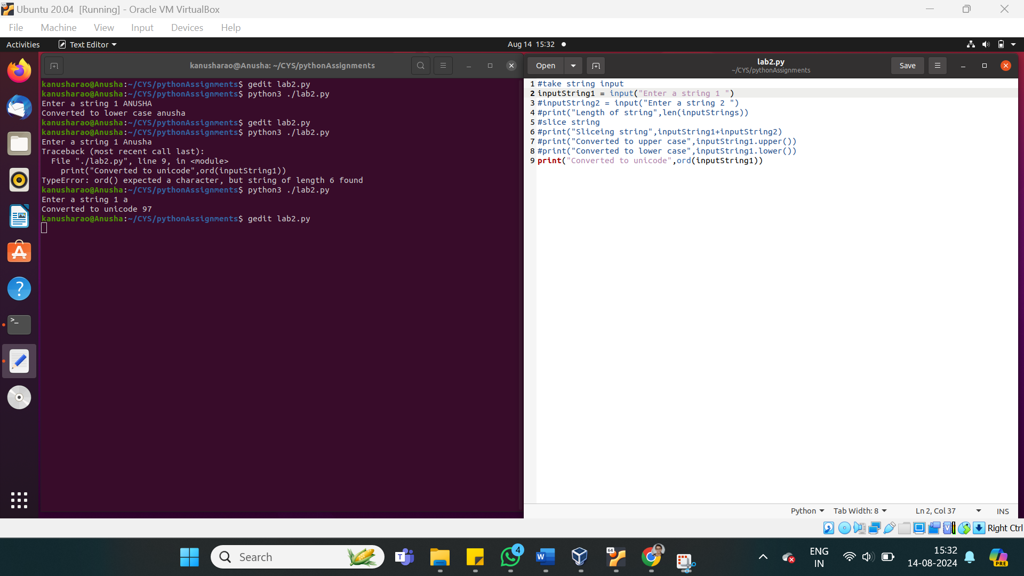

7. convert Unicode into character

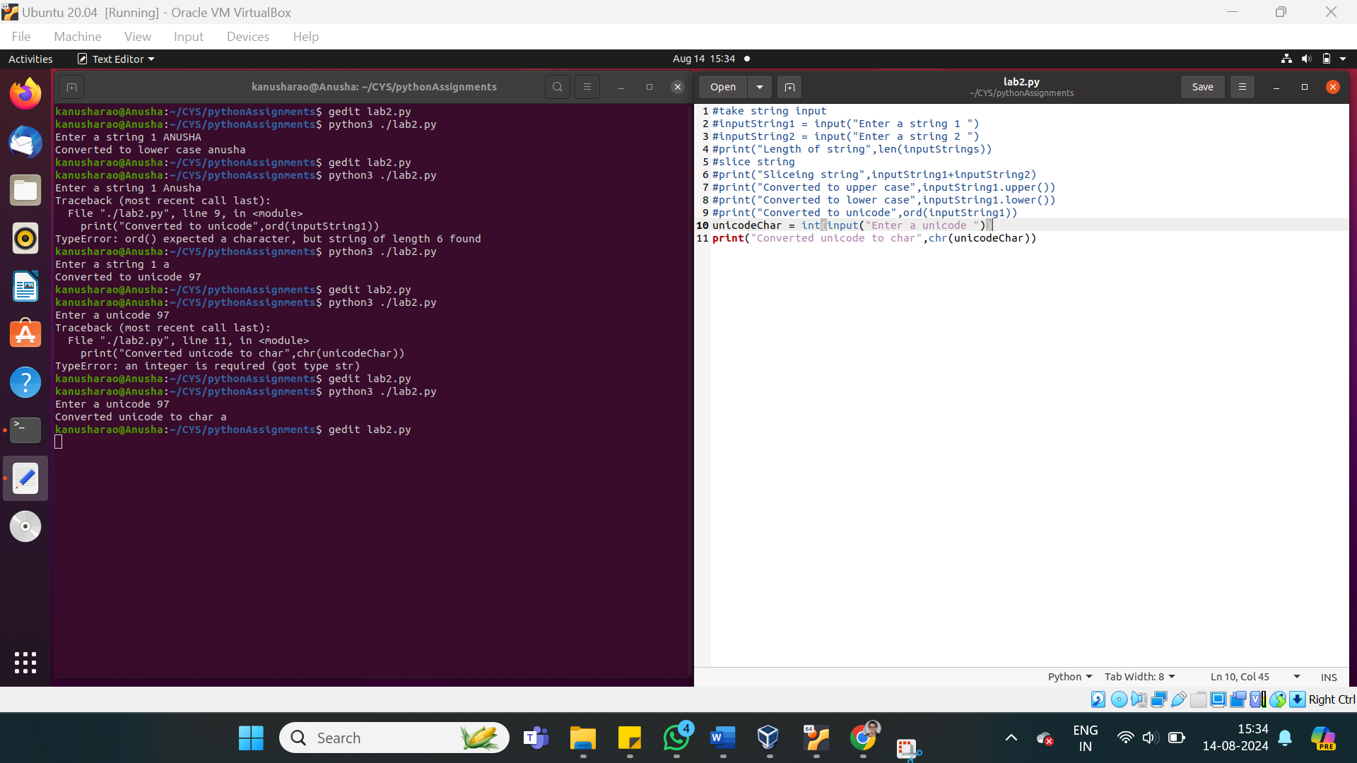

8. Check whether the given "substring" exists in the string

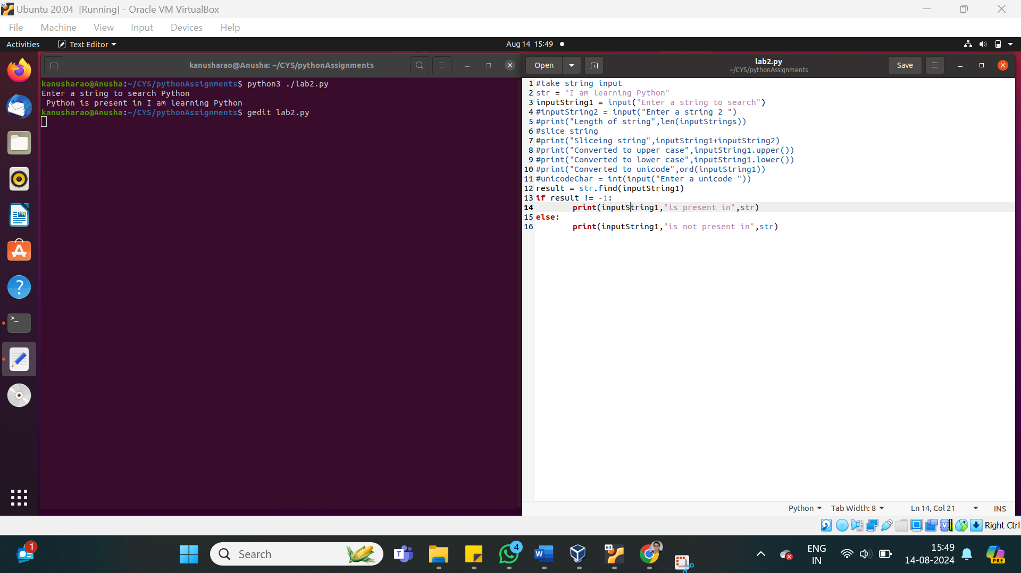

9. Replace the character 'k' with 'h'

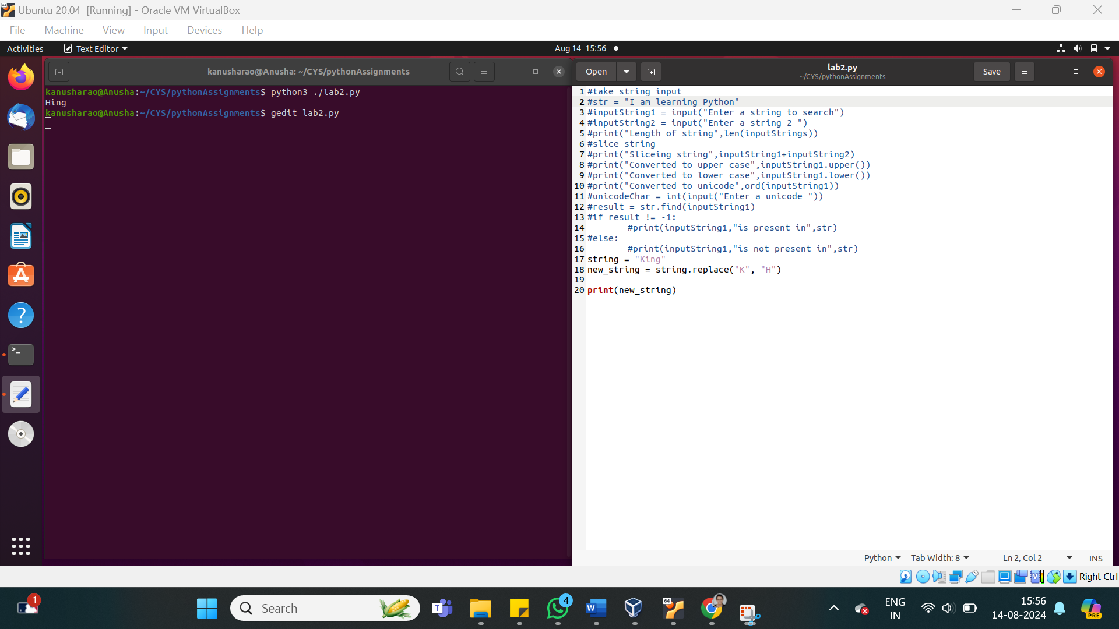

10. Pad the string with "x" at the end

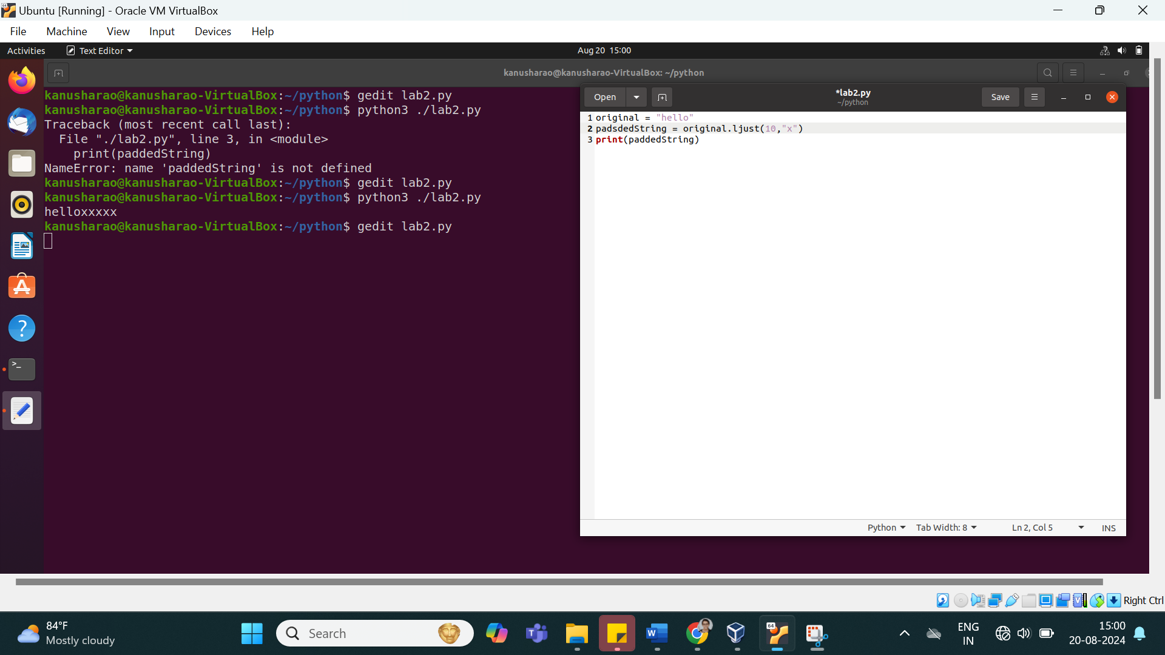

11. remove leading and trailing whitespace or specified characters from the string

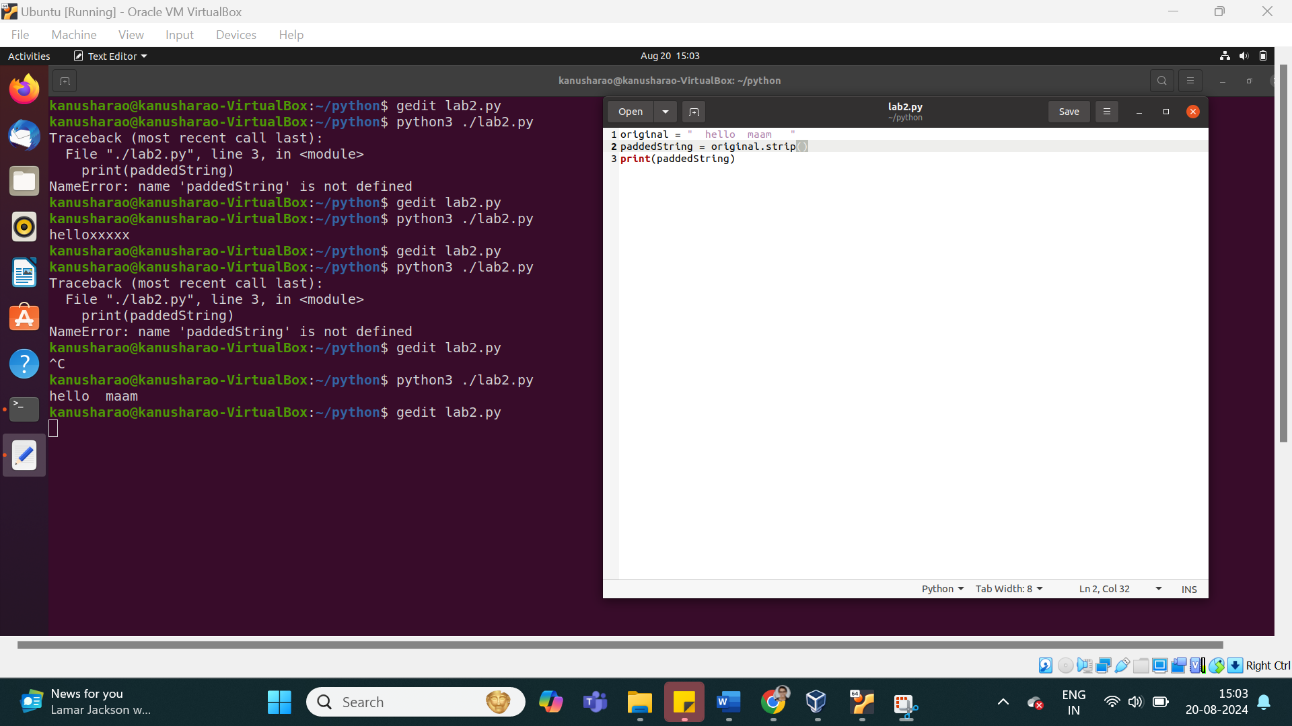

12. split the given string in to group of five characters

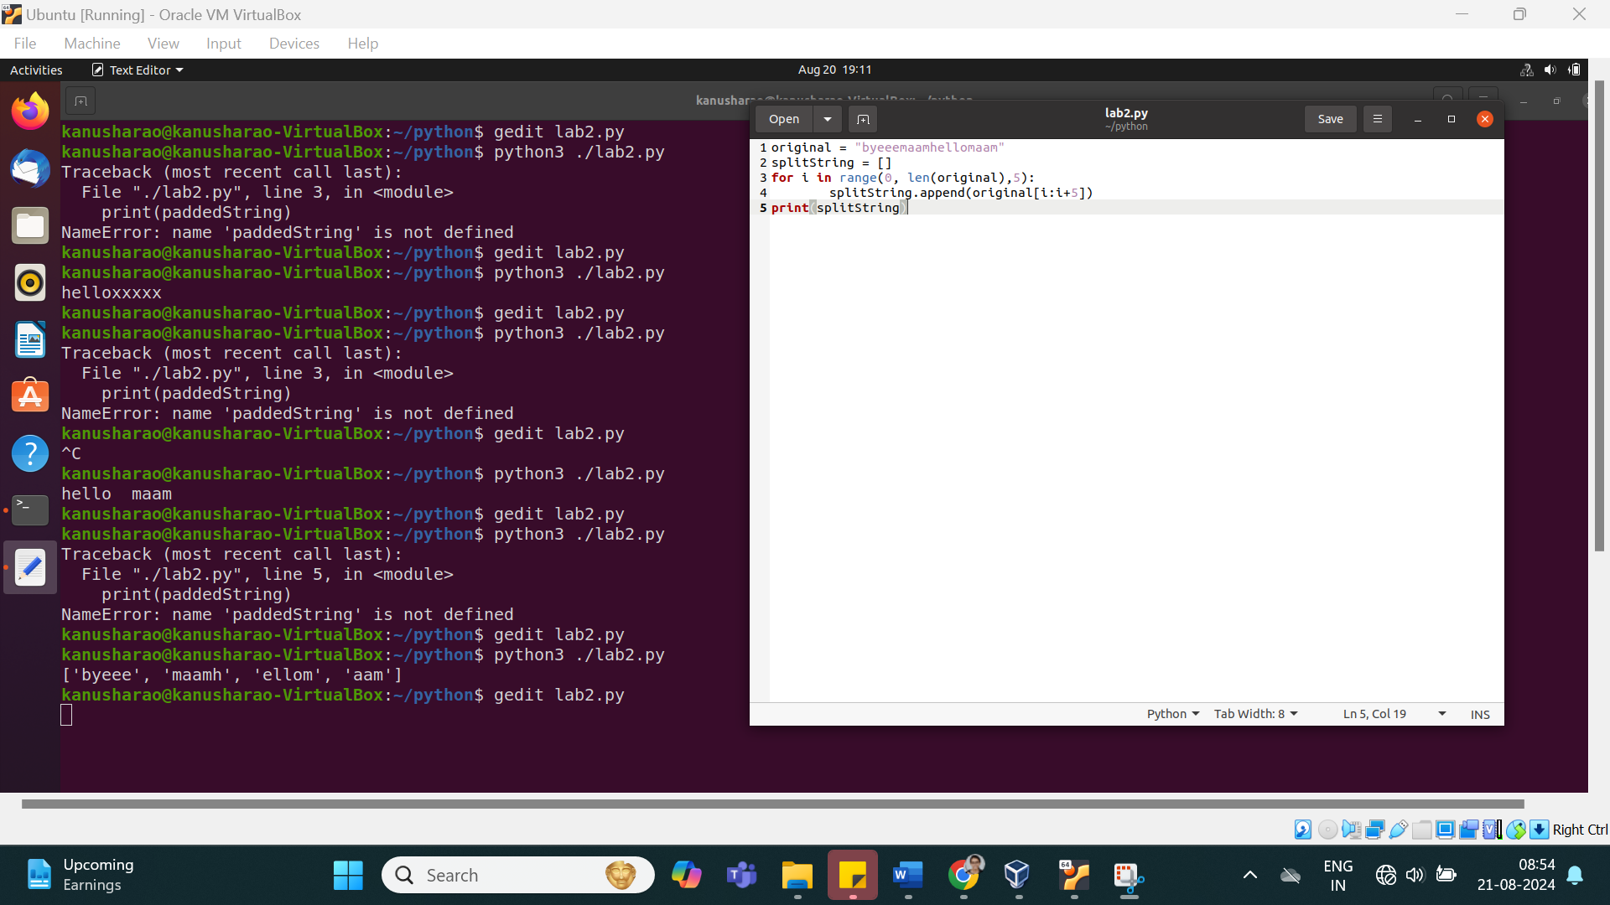

13. count total number of words

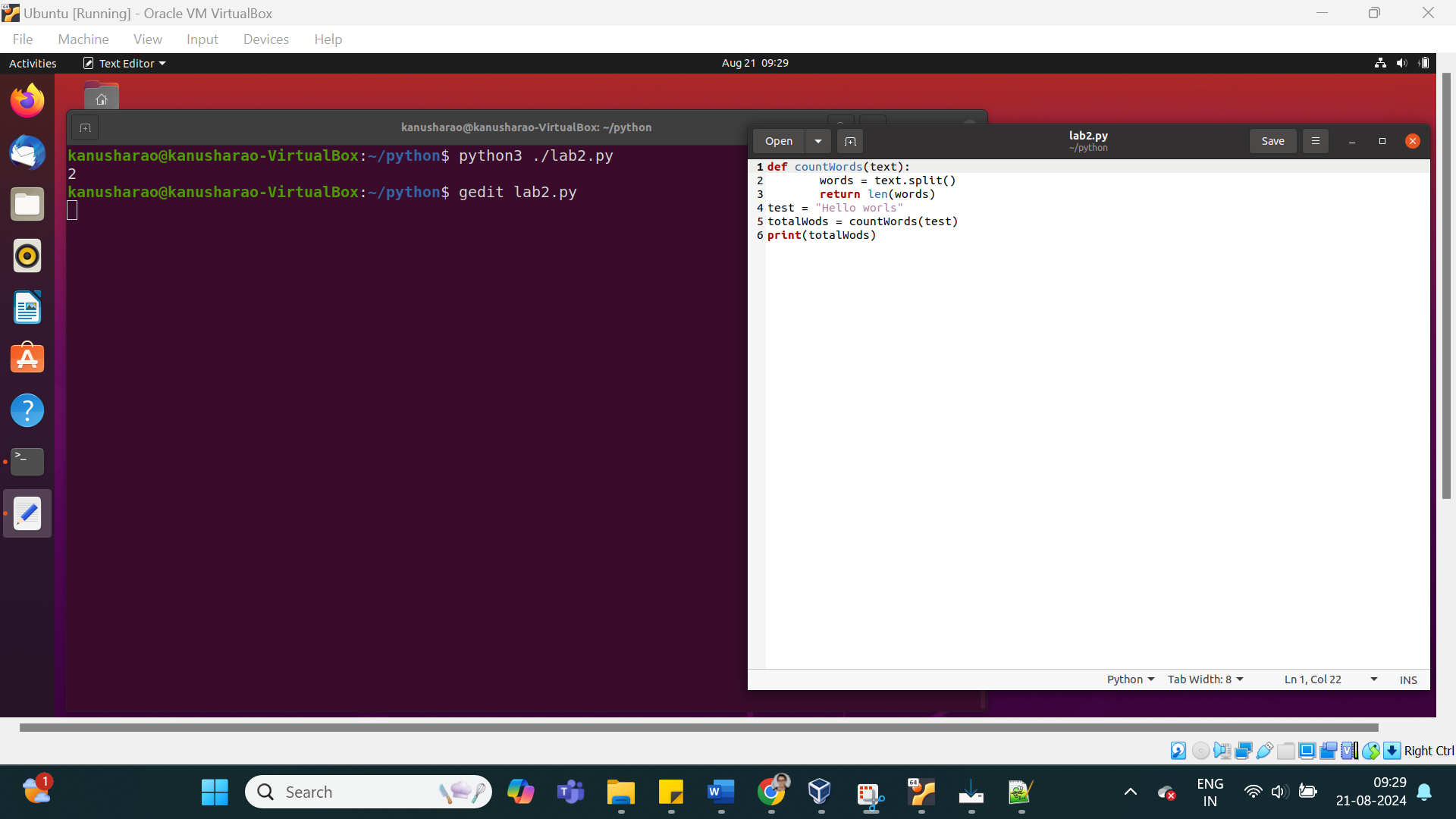

14. Find the frequency of each characters in the string

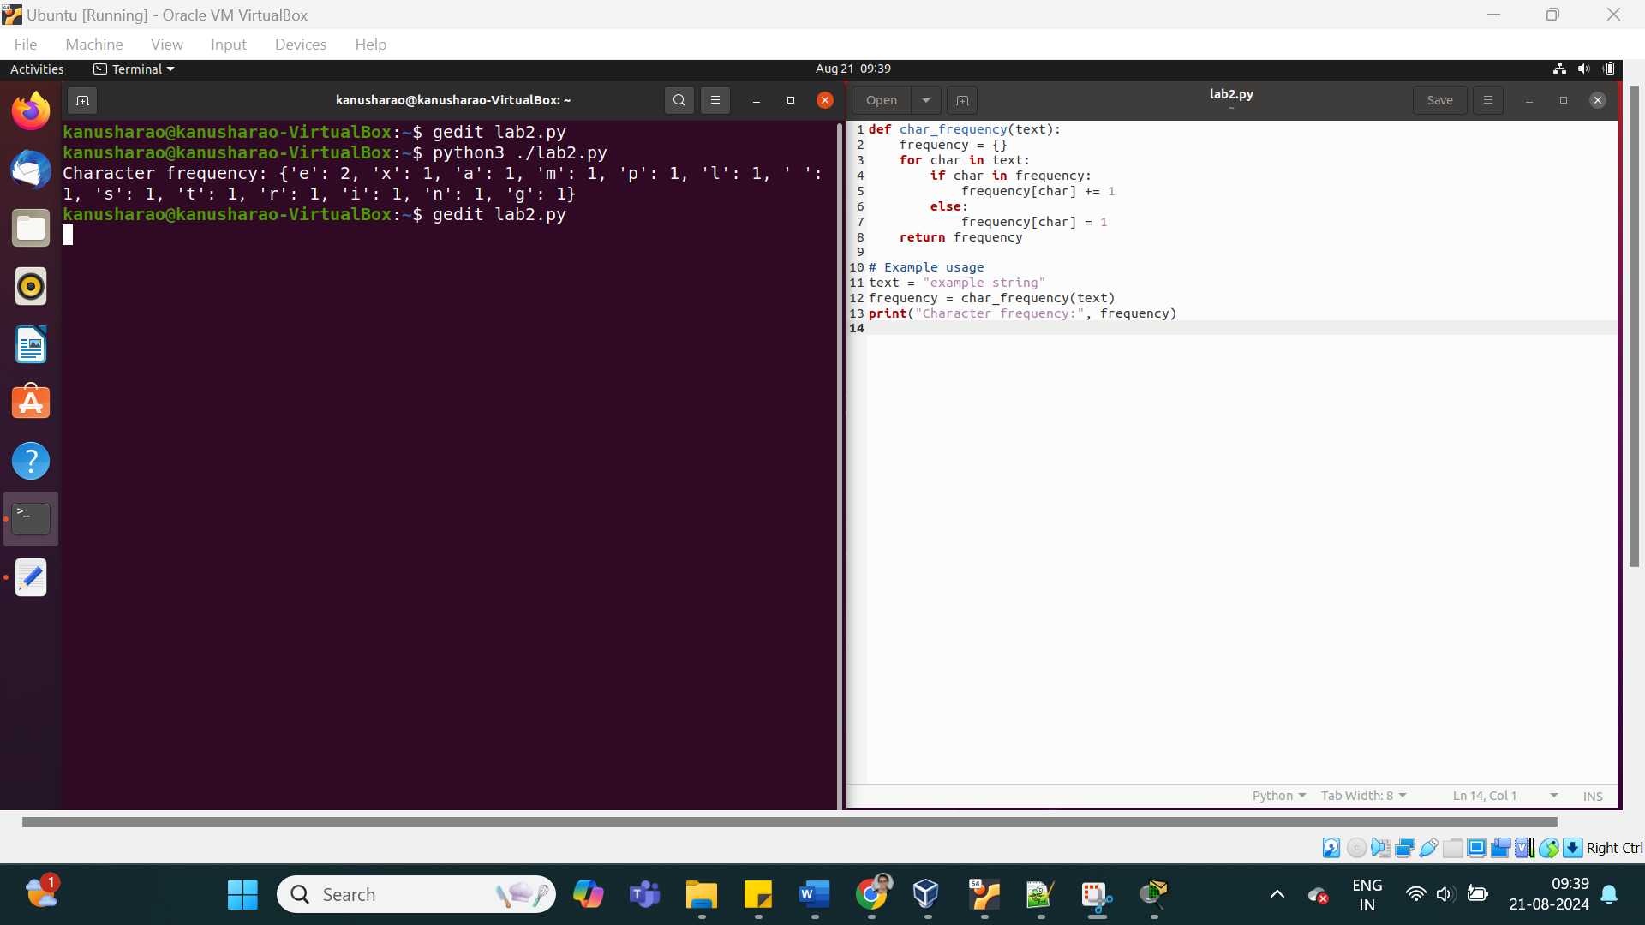

STDIN and File operators

15. get the file name from the user

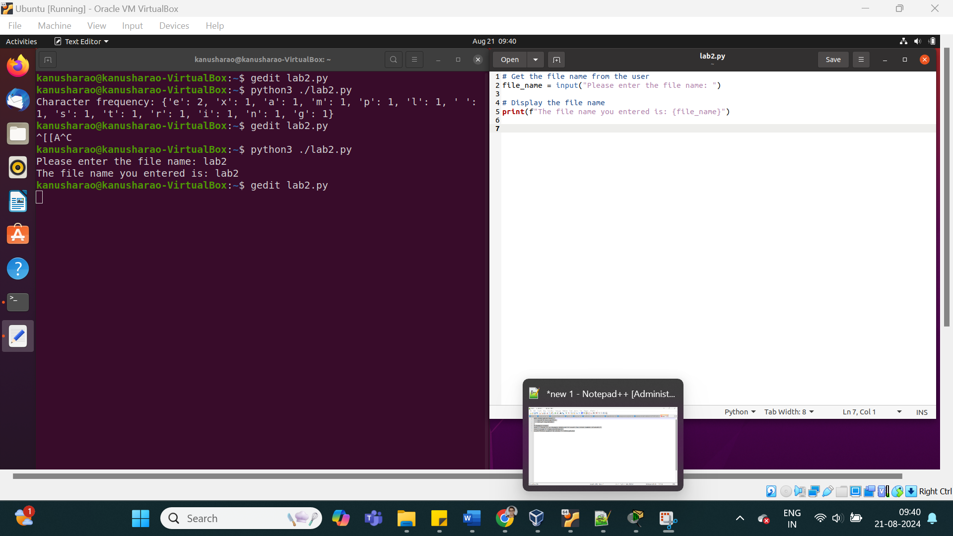

16. check the file exist or not



Looping and File handling

17. read the contents from the file

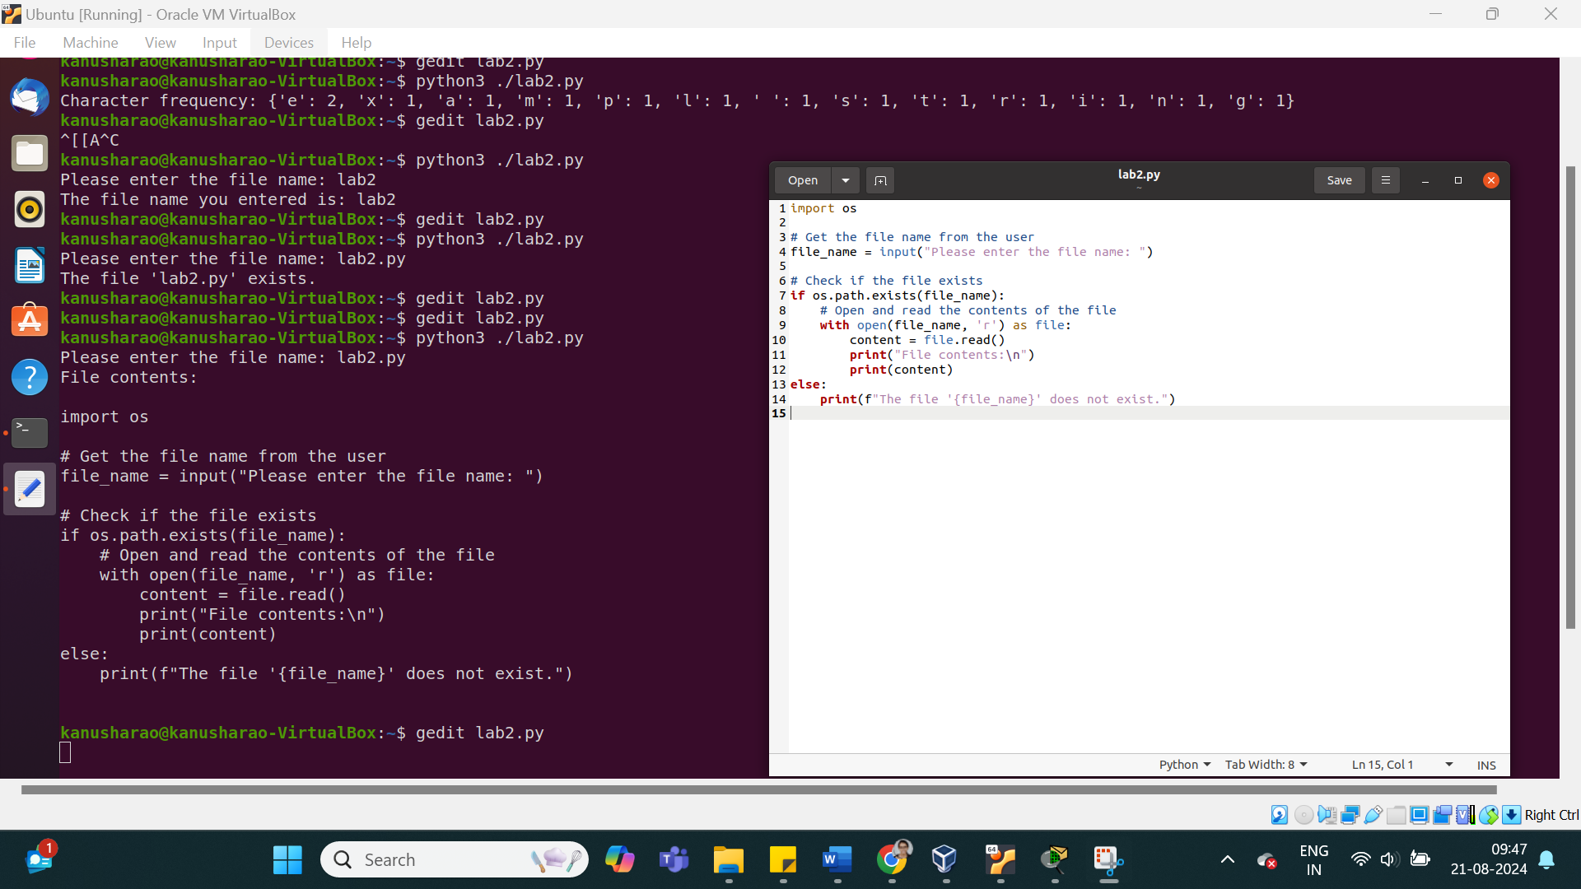

18. reverse the contents from the file

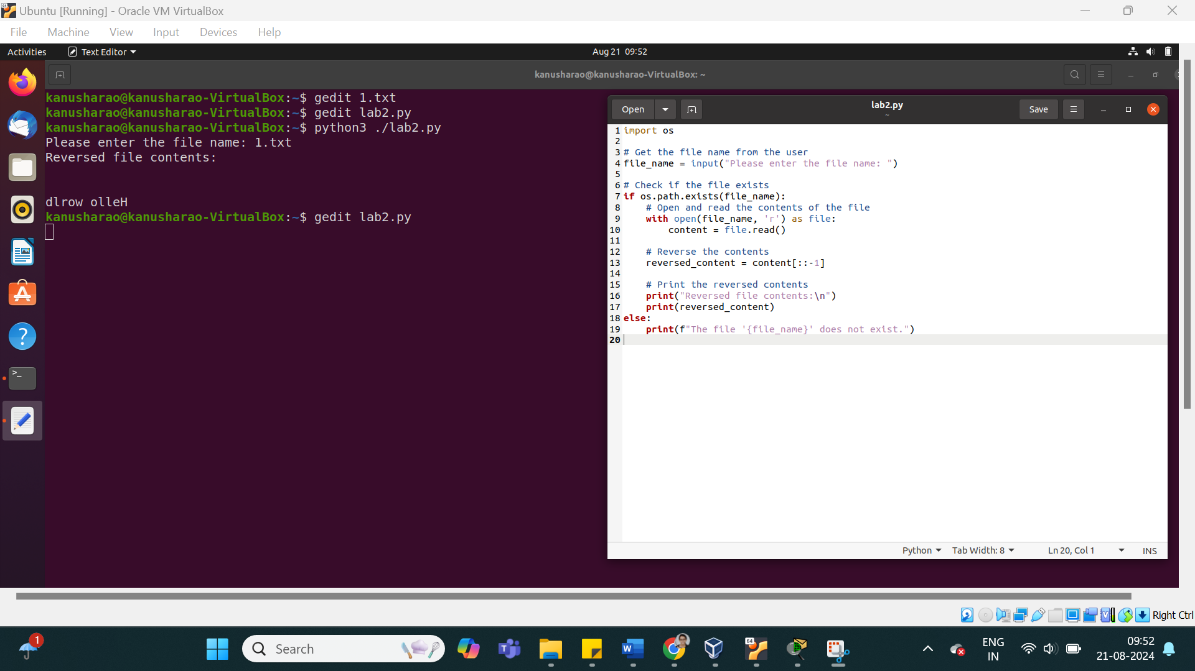

19. Write into the file

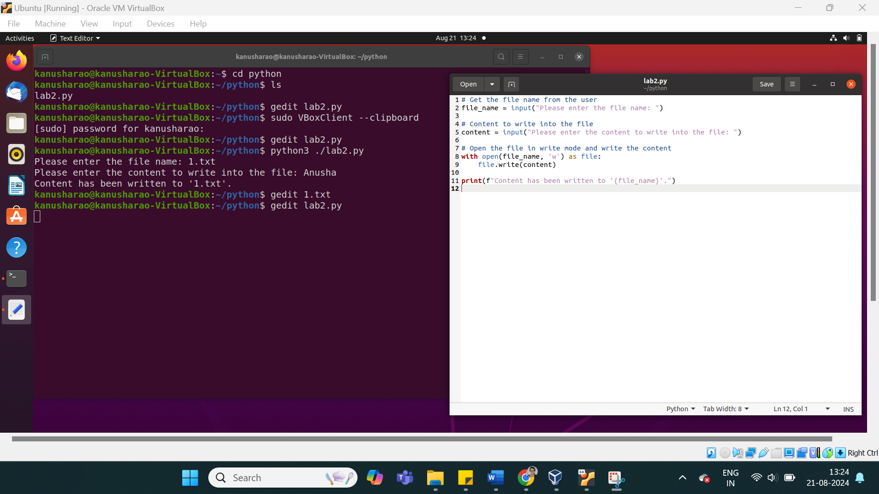

Math operations

20. convert Frequency in to percentage (continuation of 12th Question)

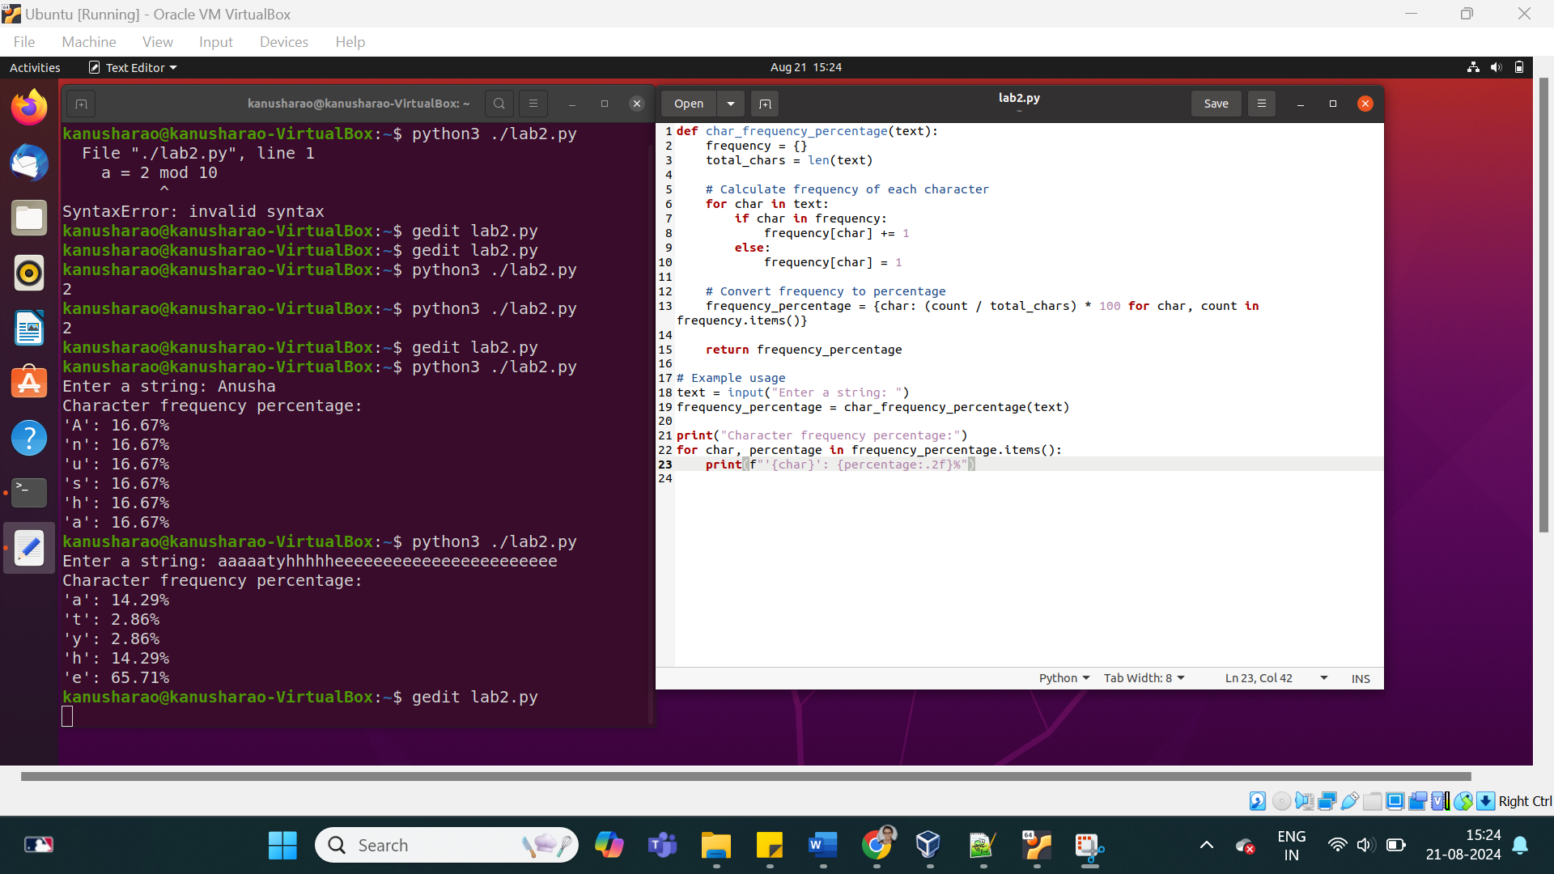

21. Perform modular arithmetic operation

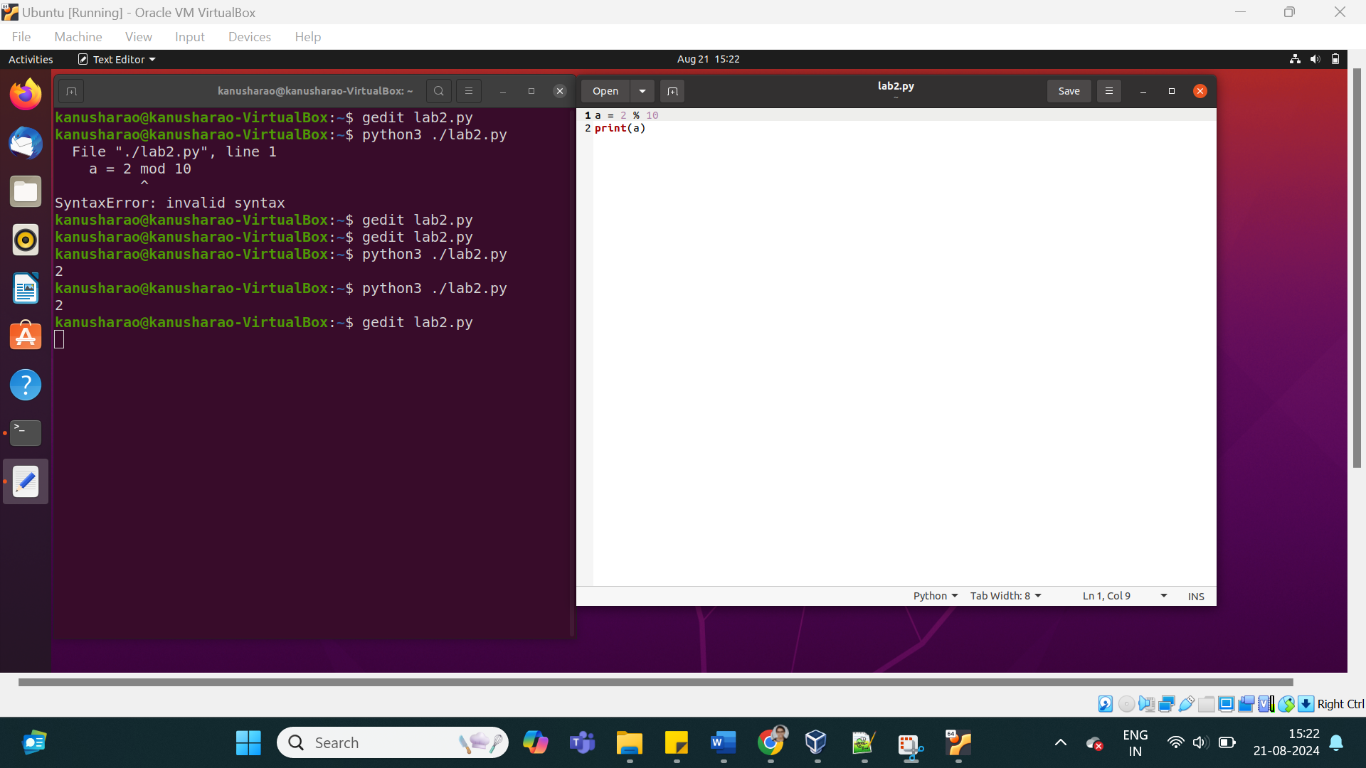

22. Find the prime numbers

check the given number is prime or not

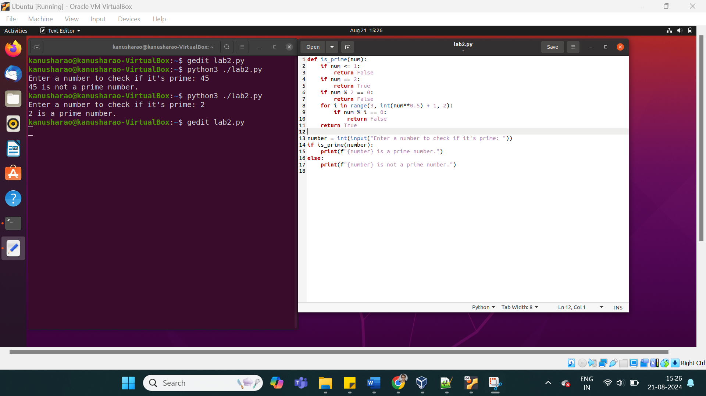

print the prime numbers with the given range

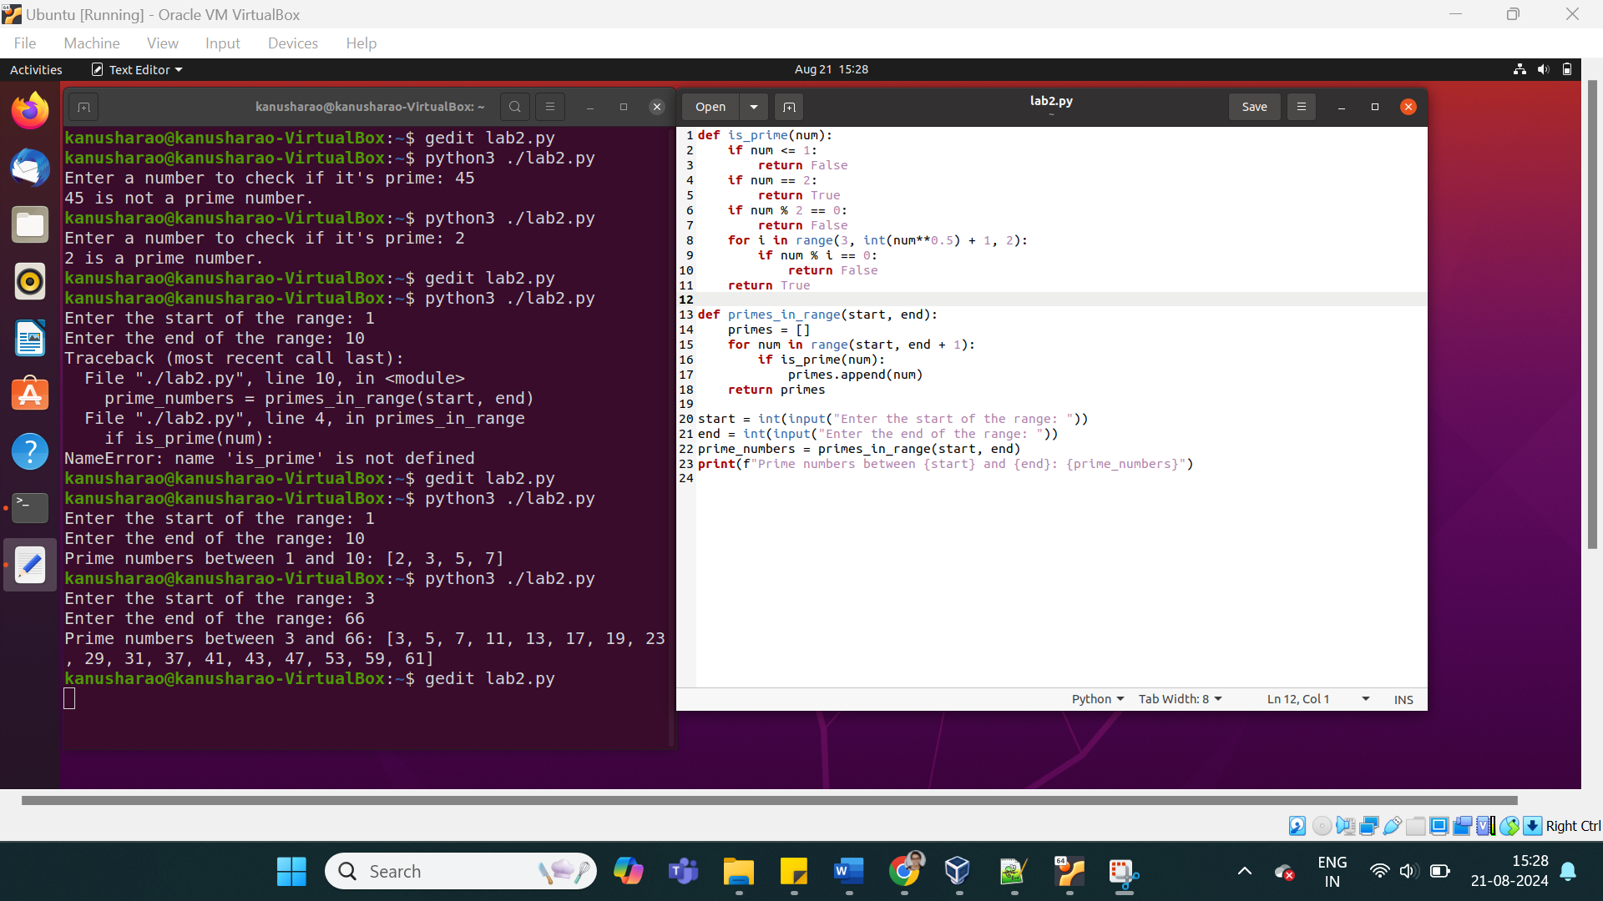

23. Check the given two numbers are co prime or not

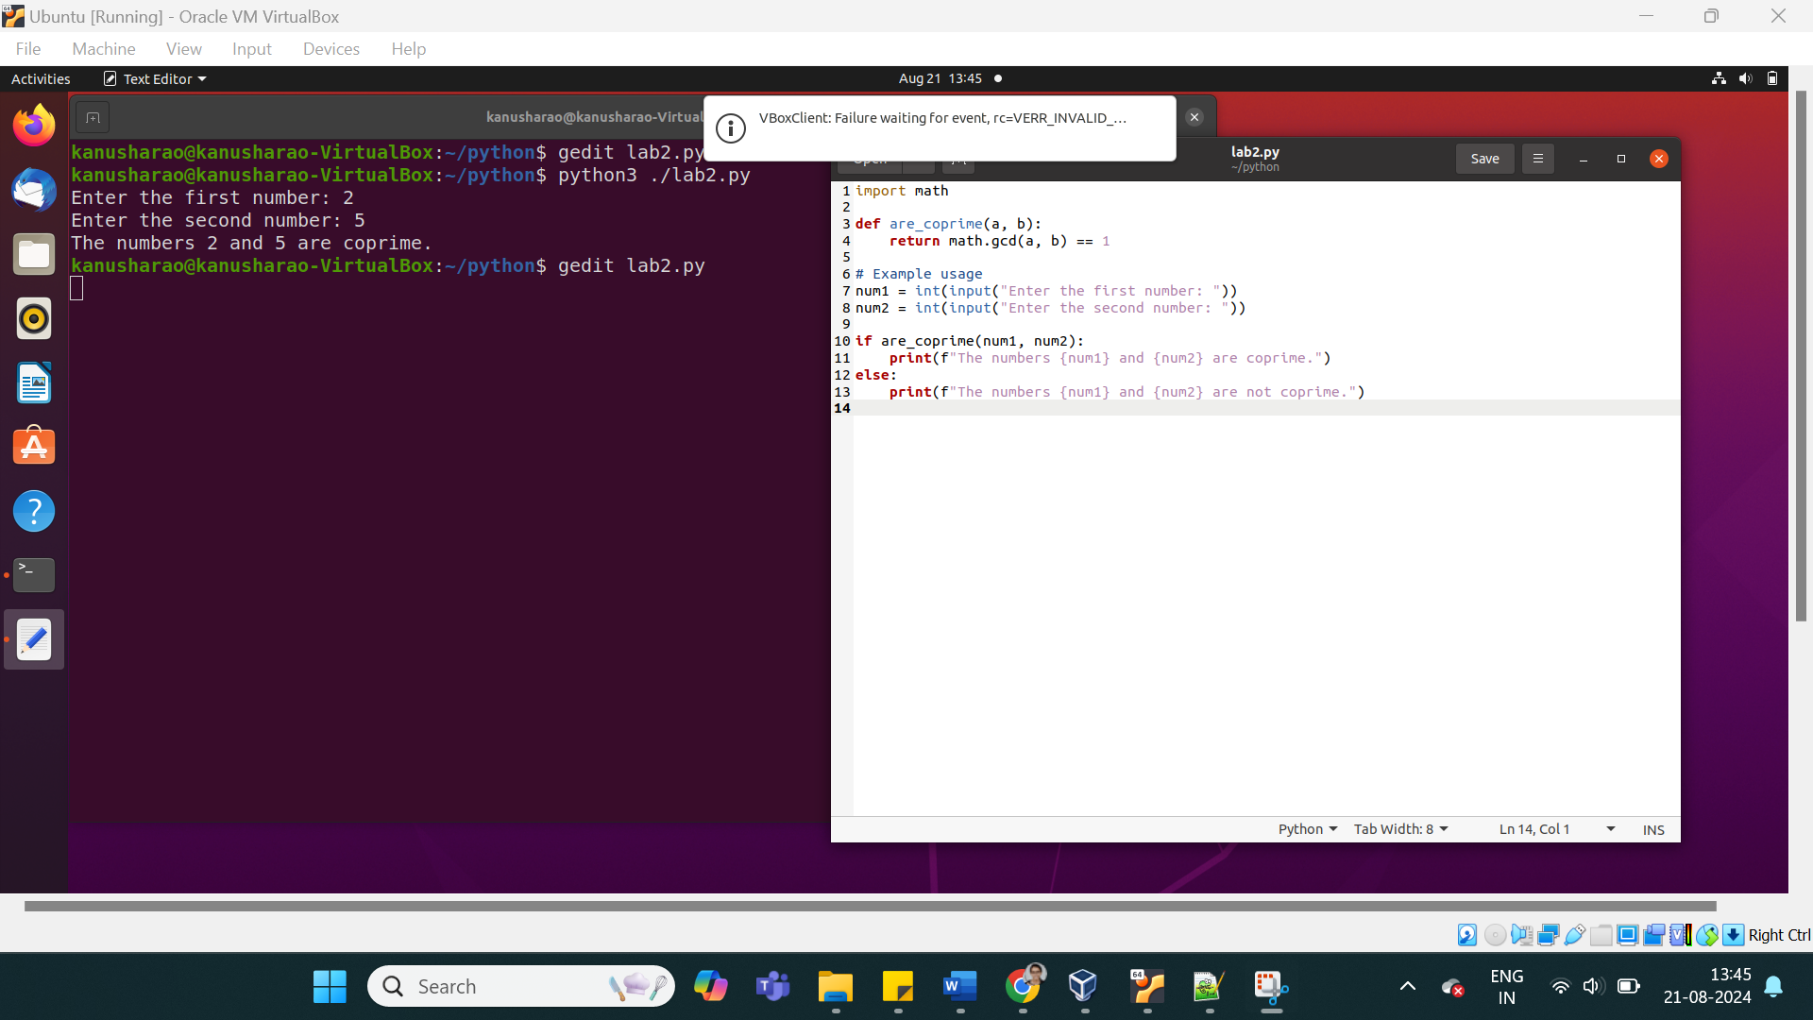

24. find the factors for the given number ( can use python library)

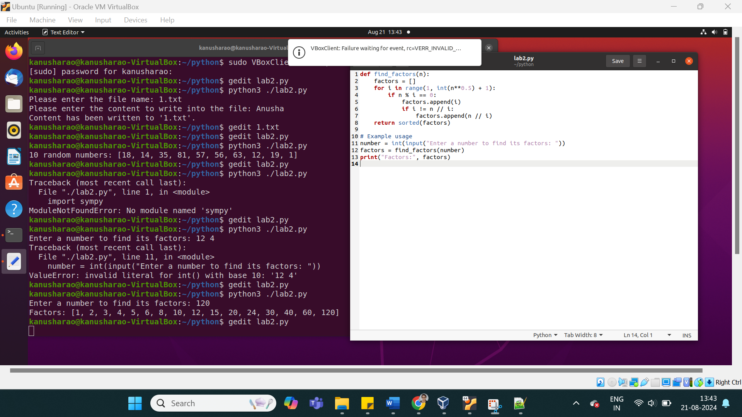

25. generate 10 random numbers

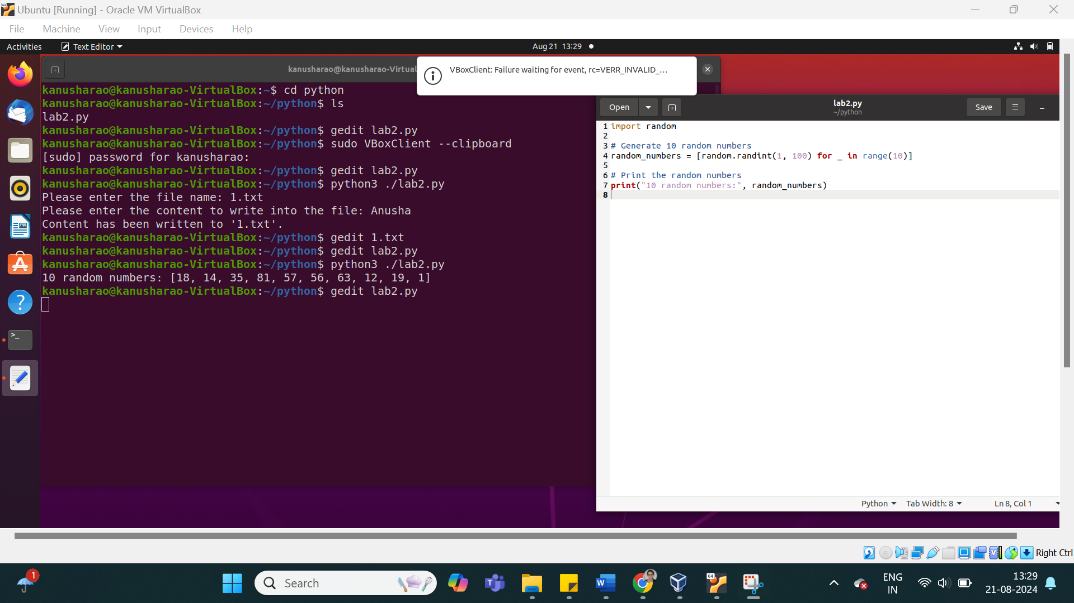

26. Explore : Miller-Rabin Test (pen paper method)

Algorithm:

// It returns false if n is composite and returns true if n

// is probably prime. k is an input parameter that determines

// accuracy level. Higher value of k indicates more accuracy.

**bool isPrime(int n, int k)**

1) Handle base cases for n < 3

2) If n is even, return false.

3) Find an odd number d such that n-1 can be written as d*2r.

Note that since n is odd, (n-1) must be even and r must be

greater than 0.

4) Do following k times

if (millerTest(n, d) == false)

return false

5) Return true.

// This function is called for all k trials. It returns

// false if n is composite and returns true if n is probably

// prime.

// d is an odd number such that d*2r = n-1 for some r>=1

**bool millerTest(int n, int d)**

1) Pick a random number 'a' in range [2, n-2]

2) Compute: x = pow(a, d) % n

3) If x == 1 or x == n-1, return true.

// Below loop mainly runs 'r-1' times.

4) Do following while d doesn't become n-1.

a) x = (x*x) % n.

b) If (x == 1) return false.

c) If (x == n-1) return true.

“Don’t worry about failures, worry about the chances you miss when you don’t even try.”

– JACK CANFIELD